K.R. MANGALAM UNIVERSITY, GURUGRAM-122103

SCHOOL OF ENGENIERRING AND TECHNOLOGY

ASSIGNMENT 2

Data Analysis with Power BI s KNIME

ETMMML174



Department: SOET | Session: 2025-27
Program: MCA (AI & ML) | Semester: 1
Course Code: ETMMML174 | College Roll no: 2501940055
Course Name: Data Analysis with Power BI & KNIME
Submitted by: Tushar Singh | Faculty: Mr. Mohammad Ajaz

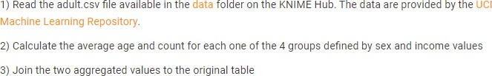

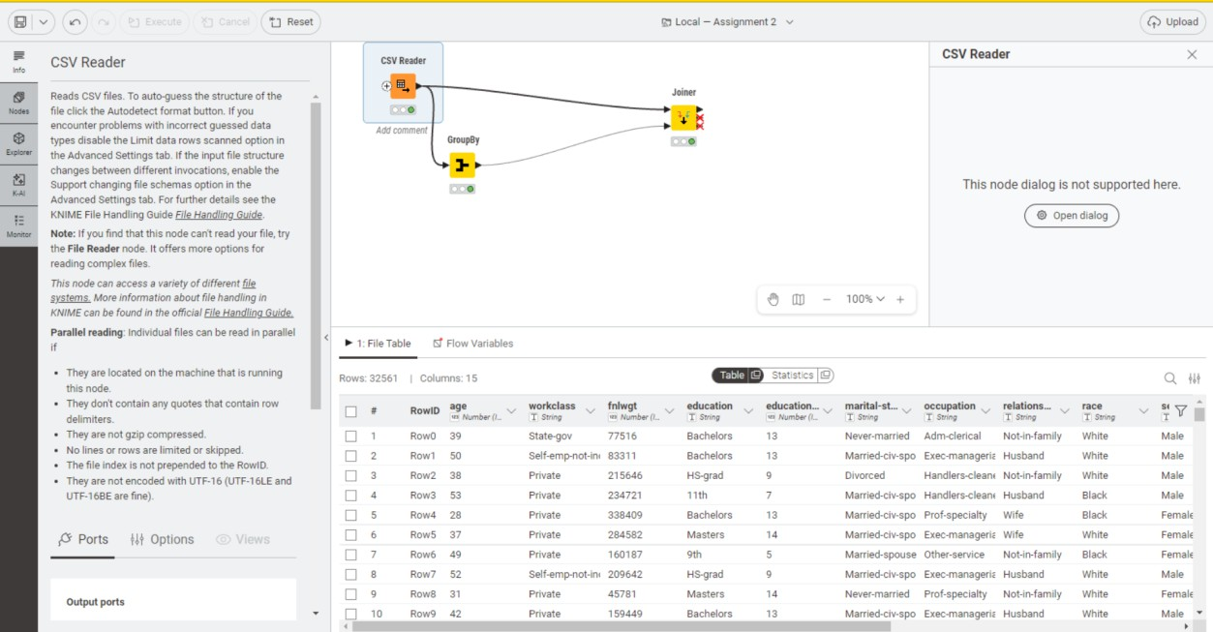
- Read the adult.csv file

- Calculate the average age and count for each one of the 4 groups defined by sex and income values

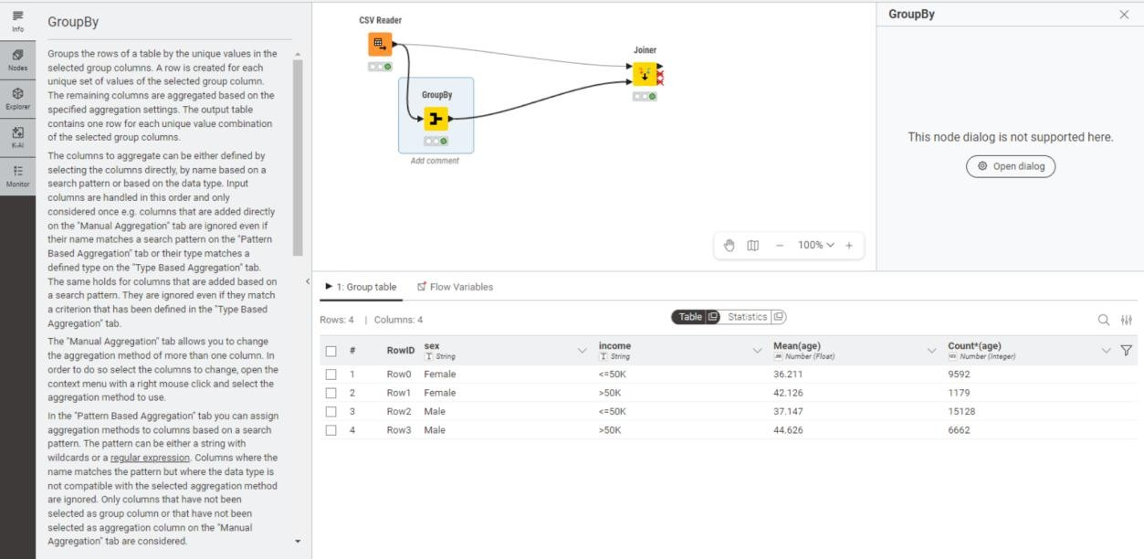
- Join the two aggregated values to the original value
